Annual Report
2025-2026



Love is the spirit of this church, and service is its law.
To dwell together in peace, to seek the truth in love,
and to help one another: this is our Covenant.

May 17, 2026

Unitarian Universalists of South Bend
801 East Washington Street
South Bend, Indiana 46617
office@firstunitarian.us
574-234-6588
firstunitarian.us

President – Gail deSomer | Trustee – Eli Williams
Vice President – Karen Dickson | Trustee – Justine Backus
Secretary – Fern Hamlin | Trustee – Ann Hoewing
Treasurer – David Mayfield | Trustee – Francisco Gomez-Dossi

Office Manager – Dr. Louise Williams | Pianist – Ian Bunker
Bookkeeper – Finda Kamanda | Nursery Care – Mackenzie Van Ausdal

Administrative | Florence Klečka | Grounds | Francisco Gomez-Dossi
Aesthetics | Melanie Smith-Guillaume | Lifespan Learning | Gail deSomer
Building | Kathy Vetter | Marketing | Dr. Louise; Cat Rambo
Building Use | Gary Metzler | Membership | Gail deSomer
Care | Gail deSomer | Nominating | Chuck Leone
DREAM Team | Gail deSomer; Kaely Barwick; Megan Sulok | Peace & Social Justice | Lois & Dan Holm
Committee on Ministry | Francisco Gomez-Dossi | Social | Kathy Platt
Endowment | Barbara Williams | Stewardship | Karen Dickson
Events | Kathy Platt | Technology | Jeremiah Cox
Finance | David Mayfield | Welcoming Congregation | Eli Williams; Dawn Nye

Minister Search – Chuck Leone | Equity – Lynn McDonald

Service Auction | Kathy Platt | Cookie Walk | Kathy Platt
Trivia Night | Florence Klečka | Dessert Auction | Kathy Platt
Love is Love Dinner | Dr. Louise | Trans Day of Remembrance & Visibility | Dr. Louise

Table of Contents

Contents
Agenda 1
President’s Report, Gail deSomer 2
Draft Congregational Meeting Minutes 3
May 18, 2025 Annual Congregational Meeting 3
June 8, 2025 Special Congregational Meeting 5
April 18, 2026 Special Congregational Meeting 6
Proposal to Become a Welcoming Congregation 8
Treasurer’s Report, David Mayfield 8
Finance Documents 9
Nominations 16
From the Nominating Committee 16
From the Board of Trustees 17
Proposal to Modify the Resolution to Implement the Endowment Fund 18
Endowment Grants 21
Proposal to Repay our Endowment 21
Funding to Repave Parking Lot 21
Funding for Automatic Opening Doors 22
Taskforce Reports 22
Minister Search Taskforce 22
Committee Reports 22
Administrative Committee 22
Aesthetics Committee 23
Building Committee 24
Building Use Committee 25
Care Committee 25
Committee on Ministry 25
D.R.E.A.M. Team (formerly Children and Youth Religious Education) 26
Endowment Committee 27
Events Committee 30
Finance Committee 31
Grounds Committee 32
Lifespan Learning Committee 32
Marketing Committee 33
Membership Committee 34
Peace & Social Justice Committee 34
Social Committee 35
Stewardship Committee 35
Sunday Service Committee 35
Technology Committee 36
Welcoming Congregation Committee 37
Congregation Wide Project Reports 38
Love is Love Dinner Date Report 38
Report on the Trans Day of Remembrance 41

Agenda
- Call to Order
- Verification of Quorum | Fern Hamlin
- Opening Words | Gail deSomer
- Volunteer of the Year Award | Gail deSomer
- Approval of Congregational Meetings Minutes | Gail deSomer
- Proposal to Become a Welcoming Congregation | Eli Williams
- Treasurer’s Report & Operating Budget | David Mayfield
- Elections for Board Officers, Endowment Committee, and Nominating Committee | Gail deSomer
- Proposal to modify the Resolution to Implement the Endowment Fund | Gail deSomer
- Endowment Grants | Barbara Williams
- Proposal to repay our Endowment | Gail deSomer
- Funding to repave parking lot | Gail deSomer
- Funding to install four automatic opening doors | Gail deSomer
- Review of Taskforce Reports, Committee Reports, and Congregation Wide Project Reports | Gail deSomer
- Adjournment

President’s Report, Gail deSomer
Our 2025-26 program year kicked off with a revival of having an annual retreat which was held at the Res. During the retreat we had an opportunity for members and friends to discuss goals for the upcoming year. We also brainstormed possible changes to our covenant in light of our previous name change. The Committee on Ministry then followed up during the year with further conversations centered on our covenant. The goals that emerged from the visioning session centered on the desire to build stronger ties within our congregation with each other and to also strengthen ties or build coalitions in the wider community, given the current dismantling of democracy.
To build community outside our doors, we publicized community events such as No Kings rallies and the work of We Make Indiana. We continued and increased our donations to Broadway Christian Parish. We held a Trans Day of Remembrance Service where several other faith communities joined with us. Through our Common Read of Social Change Now: A Guide for Reflection and Connection, we learned how organizational ecosystems can be most effective and support its members. Our newly formed Welcoming Congregation Committee has worked hard to ensure we are a congregation who shows in our deeds that we are allies and are welcoming to the LGBTQ+ community. Within our community we continue to have vibrant Sunday morning services and programing to allow deeper connection to be made and to grow. Not only does the Care Committee check up on members, it happens throughout the congregation.
The gift of approximately 1.3 million dollars from the estate of Barbara Boyd this year will provide us great potential in our future. Through a series of conversations, the majority of those attending identified they would prefer to save the funds and use earnings only and many preferred the earnings be used to assist with salaries.
The Minister Search Task Force was successful in finding a minister candidate, Rev. Jennifer Gray-Gracen will begin on August 1, 2026. We are excited to begin our co-ministry with her. Combined with our strong volunteers and programming, we look forward to the next year.

Draft Congregational Meeting Minutes

May 18, 2025 Annual Congregational Meeting
DRAFT
First Unitarian Church, South Bend
Annual Congregational Meeting
18 May 2025
I. Call to Order at 12:05pm by Chuck Leone, Board President
II. Quorum verification by Fern Hamlin, Board Secretary
There were 49 members present, 3 via Zoom, and 6 assigned proxies, for a total of 58.
III. Opening words by Eli Williams
IV. Approval of 2024 congregational meetings. Francisco Gomez-Dossi moved, and John Mitchell seconded, to approve the minutes of the 1/21/24 and 5/19/24 congregational meetings. Motion carried.
V. Update on minister search. Chuck explained the appearance of a new possible candidate for a parttime position, though nothing definite will be known until the candidate completes investigation of several other possibilities.
VI. Treasurer’s report and operating budget by David Mayfield, Board Treasurer. David noted the updated pledge total of $145,000, which increases the budgeted total income to $172,350 and the total surplus to $39,545. Appreciation was expressed to the Stewardship Committee for its work on the annual pledge drive. David shared a few budgetary visual aids and commented on significant future actions and considerations: investment of church money in CDs; possibility of our parking lot becoming a “special project” this year; and the possibility that the congregation might have to reconsider the annual budget if a minister is hired. Gary Metzler moved, and Anne Mannix seconded, to approve the proposed budget. Motion carried.
VII. Endowment grants. Chuck directed attention to page 24 of the annual report where the endowment grant recommendations are listed. There are six grants:
- $2000 for an archivist to continue our archival work
- $1000 for All Church Retreat, August 23-24, 2025, at the Mishawaka Res
- $3500 for sound system upgrade
- $1800 for conference room technical improvements
- $3800 for ADA compliance improvements for at least one door
- $5000+ for patio sun covering device
Kathy Platt explained the All Church Retreat, something we haven’t done for at least 10 years. David Mayfield moved, and John Mitchell seconded, to approve the endowment grants. Motion carried.
VIII. Elections
The Nominating Committee (Bill Stevens, Karen Dickson, Megan Sulok) presented the following slate of officers for the Board:
Karen Dickson, vice president
David Mayfield, treasurer
Justine Backus, trustee
Ann Hoewing, trustee
The following members will remain on the Board next year: Gail deSomer, president; Fern Hamlin, secretary; Eli Williams, trustee; Francisco Gomez-Dossi, trustee. There being no nominations from the floor, Melanie Smith-Guillaume moved, and Marilyn Shaul seconded, to approve the slate as presented. Motion carried.

The Nominating Committee presented the following slate for the Endowment Committee:
Linwood Bailey, term to expire in 2028
Francisco Gomez-Dossi moved, and John Mitchell seconded, to approve the slate as presented. Motion carried.

The Board of Trustees recommended the following slate for the Nominating Committee:
Chair Chuck Leone, outgoing Board President, for 1 year
Member Eli Williams, for 2 years
Alternate Melanie Smith-Guillaume
(Megan Sulok is a continuing member of the committee with a term to expire in 2026.)
Bill Stevens moved, and Francisco Gomez-Dossi seconded, to approve the slate as presented. Motion carried.
IX. Update on name change process. Chuck explained that the Board of Trustees proposed a separate meeting with the single agenda item of the church name change, in order to devote adequate time to discuss the options in detail, said meeting to take place 3 weeks from today, 8 June 2025, 12noon. So moved by Dan Holm, seconded by Dawn Nye. Subsequent discussion emphasized that the meeting would be to discuss and vote on the name change; Dan and Dawn both agreed with that. Chuck explained that the discussion process would include several straw votes, in an attempt to clarify what church members were thinking about such a change, culminating in a final decision. Dr Louise Williams commented that such a process should be fully explained before the meeting, Chuck agreed that possibilities for this would be explored. He also explained the rationale for making the change a Doing Business As rather than replacing our incorporation documents with a new name. The results of our internal church conversations about a name change will also be made available. Motion carried.
X. Review of committee reports. Committee reports are contained in the Annual Report. Additionally, Florence Klecka moved, and Dr Louise Williams seconded, that the minutes of this meeting reflect the inclusion of the Administrative Committee’s report in the church’s Annual Report, which will be available on the church’s website by tomorrow (5/19/25). Motion carried.
XI. Volunteer of the year award. Chuck pointed out that our volunteer of the year award does not always result from big and flashy contributions to the church community, but rather for someone who is frequently there when needed, doing whatever needs to be done, quietly getting things done. In this spirit, the volunteer of the year award is gratefully presented to John Mitchell.
XII. Adjournment. Chuck Leone invited a motion to adjourn. Francisco Gomez-Dossi and Bill Stevens obliged. Motion carried and the meeting was adjourned at 1pm.
Submitted by
Fern Hamlin, Board Secretary

June 8, 2025 Special Congregational Meeting
DRAFT
Special Congregational Meeting
First Unitarian Church, South Bend
8 June 2025
The meeting was called to order by Chuck Leone, Board President, at 12:05pm. The sole purpose of this meeting is the question of the church’s name.
Fern Hamlin, Board Secretary, confirmed that a quorum was present. There were 50 members present, 7 proxy forms, and 3 people on zoom, for a total of 60.
Chuck explained the background for the board’s recommendation that the name change be a Doing Business As name which would mean that we continue to be recognized legally as a church, and as such we would continue to receive the tax benefits and legal protection afforded to religious organizations. It will cost us $26 to file Doing Business As paperwork with the state.
There will be several elements of the name change to consider, and the process will work through a series of straw votes, to ascertain support or lack thereof for the different elements, culminating in a formal vote.
The first question was whether we did want to change the church’s name or keep it the same. Comments for not changing the name included questioning the financial aspect and whether or not the benefits would outweigh the costs. Those speaking in favor of a name change noted the desire to add “universalist,” the fear/turn-off factor of the word “church” in our name, the need to attract younger members if we want the church to continue, the need for a modern-forward-facing-inviting name for both us and the community. 46 wanted to change the church name, 6 did not.
The next question was whether or not to add the word “universalist” to the church name. 51 wanted to add it, 3 did not.
Next, did we want to omit the word “First” from the church name. 43 said yes.
Did we want to omit the word “Church” from our name. 42 said yes, 3 said no.
Did we want to include some kind of descriptor word in our name, since we are not using the word “church” -- something like congregation or community -- or did we not want any descriptor word. 41 did not want any descriptor word, 5 did.
Did we want to include a location name -- just South Bend, or South Bend, Indiana? 47 wanted South Bend only, 3 wanted South Bend, Indiana.
Gail deSomer moved, and Francisco Gomez-Dossi seconded the motion that we adopt the Doing Business Name of Unitarian Universalists of South Bend. Chuck called for a voice vote to adopt this DBA name and the motion carried.
The meeting adjourned at 1:30pm.
Fern Hamlin, Board Secretary

April 18, 2026 Special Congregational Meeting
DRAFT
Special Congregational Meeting
Unitarian Universalists of South Bend
12 April 2026
The meeting was called to order at 12:15pm by Gail deSomer, board president. The sole business of this special meeting is to confirm the contract with Rev Jennifer Gray-Gracen.
Fern Hamlin, board secretary, confirmed the existence of a quorum: 42 members are present, plus 5 on zoom.
Gail presented a summary of the work of the search task force, including the decision to search for a full-time minister and not to pay the absolute minimum suggested by the UUA for a congregation of our size, with both of which the board agreed. The goal was a two-year contract.
A video greeting/introduction from Rev Gray-Gracen followed.
Chuck Leone made the following motion to hire the minister:
I move that First Unitarian Church, South Bend, also known as Unitarian Universalists of South Bend, hire Rev Jennifer Gray-Gracen as the minister of the church effective August 1, 2026, at the starting annual salary of $82,100.00 with such other benefits and compensation, and under such terms and conditions as are set out in the agreement between the church and Rev Gray-Gracen which has been approved by the Board of Trustees and has been made available to the members of the church for review.
Jeremiah Cox seconded the motion.
A handout, prepared by David Mayfield, board treasurer, set out the financial breakdown of the proposed contract and the contract’s likely impact on the church operating budget.
Discussion followed:
Jim Ward thanked all involved in the search.
Anne Mannix--What are Rev Gray-Gracen’s strong and weak points? Gail deSomer, search task force member, pointed to her numerous trainings in many areas of church management and her well-rounded resume. Chuck Leone, search task force member, noted that she receives high marks from her current congregation in Cincinnati.
Elena Wake--Can we call her as our settled minister after the 2-year contract? Gail deSomer--Yes we can, since she’s coming here as a contract minister and not as an interim minister.
Jerry Brooks--Will she be moving to South Bend? Gail deSomer--She will live within 15 miles of South Bend.
Kathy Vetter noted that she had met Rev Gray-Gracen when Rev Gray-Gracen was doing community service in our building, about 5 years ago, and Kathy had thought then that Rev Gray-Gracen would be a good match for our congregation.
Melanie Smith-Guillaume--After 2 years would the ministerial compensation package be higher? Gail deSomer--There is no cost of living adjustment in the contract, so the board would have to decide what it wanted to recommend to the congregation.
Barbara Williams--What percentage of the church budget income does the ministerial compensation account for? Jeremiah Cox, search task force member--About 73%.
David Mayfield noted that though only a two-thirds vote is required to approve the contract, a candidate might not want to accept for that minimum number.
Jim Curlee asked where the money to pay the minister will come from. Gail deSomer--We currently have about $100,00 in savings, in certificates of deposit. In the second year we will probably need money from the Boyd legacy. For a third year we would have to decide how we would pay for a minister.
Anne Mannix supports the motion but asks if the money from the Boyd legacy would come from interest or the principal. David Mayfied, board treasurer, explained that we cannot predict what the return from the money will be in the UUCEF. Approximately $70,000 would be needed from the Boyd legacy for the second year of the contract.
Dan Holm--If we approve the contract but not the annual budget we would still be committed to the minister. We would have to work to produce an approved budget.
Byrd Tetzlaff--A new minister will probably enlarge our membership.
Megan Sulok commented that she is excited about this prospect and grateful for the search task force, adding that the Sunday Service committee is tired after 2 years of providing Sunday services.
Marilyn Shaul moved to call the question, David Wistreich seconded.
The motion was approved unanimously, with 54 votes in favor, none opposed or abstaining.
Jeremiah Cox moved, and Catherine Lundergan seconded, to adjourn the meeting.
The meeting was adjourned at 12.55pm
Fern Hamlin
Board secretary

Proposal to Become a Welcoming Congregation
A proposal from the Welcoming Congregation Committee will be presented at the meeting.

Treasurer’s Report, David Mayfield
This year has been my second full year as treasurer. The church has seen several positive monthly balances due to the lack of spending from line items 900-945 (minister-related costs). The current year’s budget assumed no minister and half-time office administrator with insurance and a bookkeeper. Without the minister-related costs, we are enjoying a surplus of just over $53,000. The Sunday Service Committee lines have of course increased, but I predict we will see our fiscal year-end surplus at about 35% positive as compared to approximately 20% positive last year.
The two assistant treasurers remain officially appointed, Fern Hamlin and Kathy Vetter. They and the other committee members, Janet Bogar, Karen Dickson and Barbara Williams, and our excellent bookkeeper Finda Kamanda, have made your church’s financial business run smoothly. We owe them all great thanks.
Over the last year:
The Finance Committee has again created a list of Authorized Signatures for Budget Line Items, to name who is responsible for approving spending in each expense category.
We continued to utilize the UU Org Retirement plan. This allows us to offer a 5% base and 0% match for all employees who work 1,000+ hours per year. At our fiscal year-end, this will be changed to 10% base and 0% match, as we must offer all employees equal benefits, and the minister contract has been unanimously approved by our congregation. Health care benefits will also be adjusted.
With BOT approval, we moved a larger portion of our assets from checking into CDs, which have started to earn interest. We have been rolling over CDs regularly. As of now, we will have a total of more than $110,000, earning approximately 4%. We have started a savings account at CommunityWide Credit Union. This account allows us to access higher rates on CDs.
As you are aware, Barbara Boyd’s gift to the church was first placed in a CD where it earned 4.25% APY for 6 months. In April, that CD matured and the BOT approved the Finance Committee’s recommendation that it be invested with the UUCEF, in a separate account named the Boyd Fund. Unlike the CD, this account is subject to greater risk, but it has the opportunity for much greater gains and the possibility of loss.
The 2026-2027 proposed budget reflects our current levels of spending, assumed for the entire upcoming fiscal year. It includes the congregation hiring a minister at the contract rates that have been approved.
This year’s proposed budget has the largest deficit ever for the church.
Note: Limits on BOT spending remain maximum 3% over the total budget on any one item and no more than 5% over the total budget without congregational approval.
If you are interested and have considered joining the Finance Committee, please contact me.
Sincerely,
David Mayfield

Finance Documents

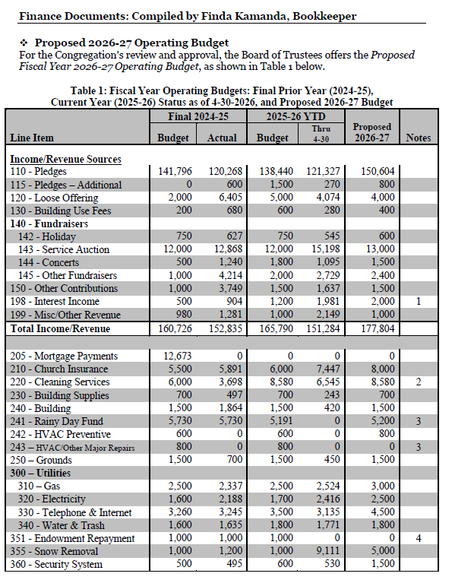

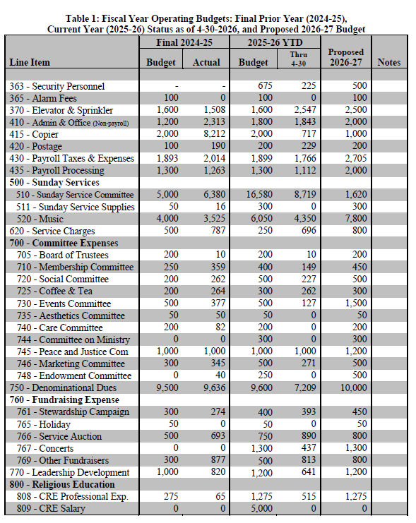
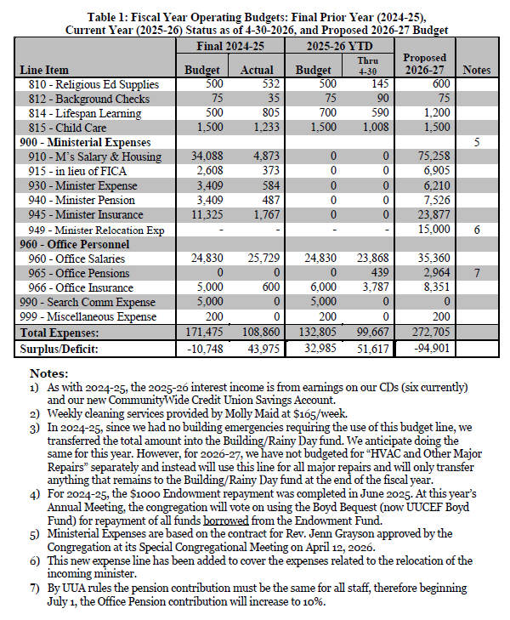
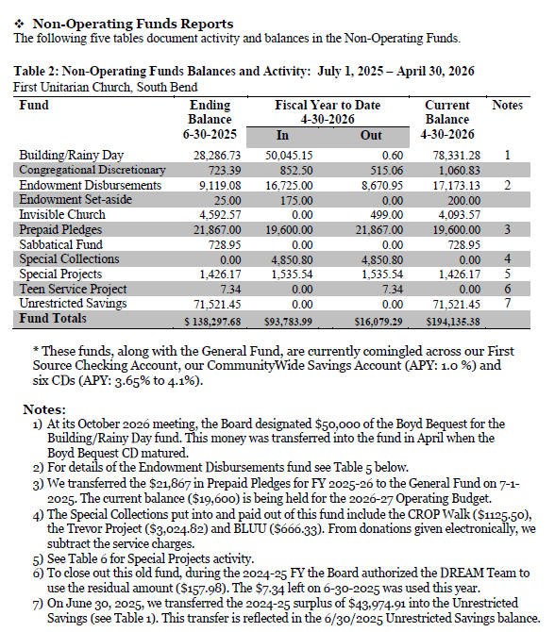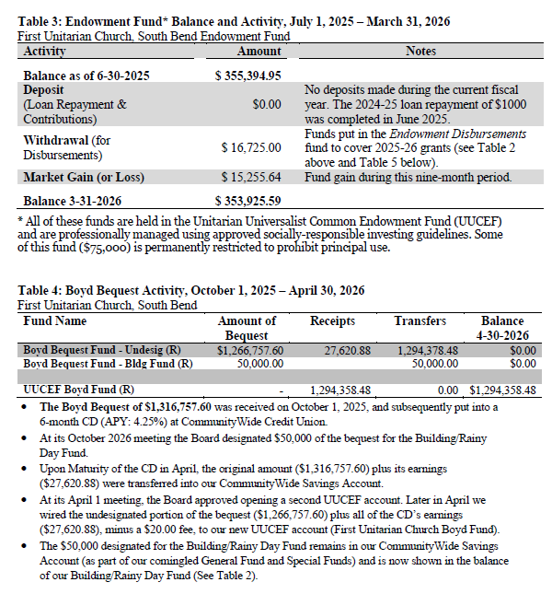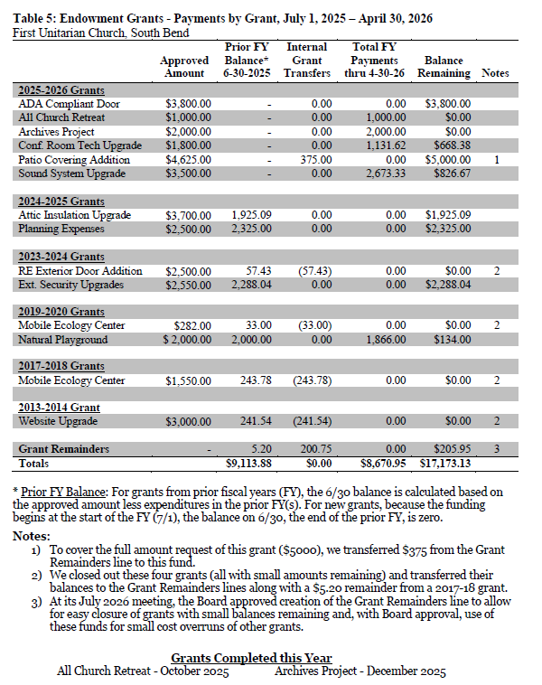
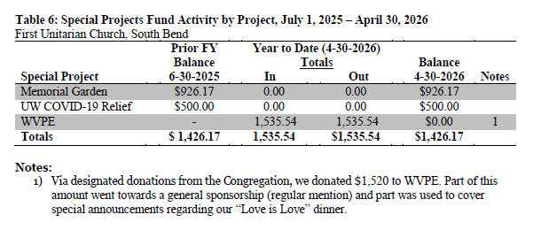

Nominations

From the Nominating Committee
The Nominating Committee is pleased to present the following slate of nominations for the 2025-2026 Board of Trustees and the Endowment Committee:
Board of Trustees
Vice President: Francisco Gomez-Dossi
Secretary: Fern Hamlin
Trustee: Ben Tovar
Trustee: Cat Rambo
These terms expire in June 2028.
For information purposes only, the continuing members of the Board are Karen Dickson (President), David Mayfield (Treasurer), Justine Backus (Trustee) and Ann Hoewing (Trustee) with terms expiring in June 2027.
Endowment Committee
John Mitchell for a term expiring in June 2029.
For information purposes only, the continuing members of the committee are Barbara Williams (term expiring in June 2027) and Linwood Bailey (term expiring in June 2028).
Submitted by the Nominating Committee
Chuck Leone, Megan Sulok, Eli Williams

From the Board of Trustees
The Board of Trustees is pleased to nominate the following members to serve on the 2025-2026 Nominating Committee:

Chair | Jim Ward | 1 year
Member | Dawn Nye | 2 years
Alternate | Cat Rambo | 1 year

For information purposes only, Eli Williams is a continuing member of the committee with a term to expire in 2027.

Proposal to Modify the Resolution to Implement the Endowment Fund
We are proposing two major changes primarily to part B:
- Grants may be submitted twice a year. Previously only once a year.
- Guidelines regarding unused funds. See part B section 2 paragraph 5.
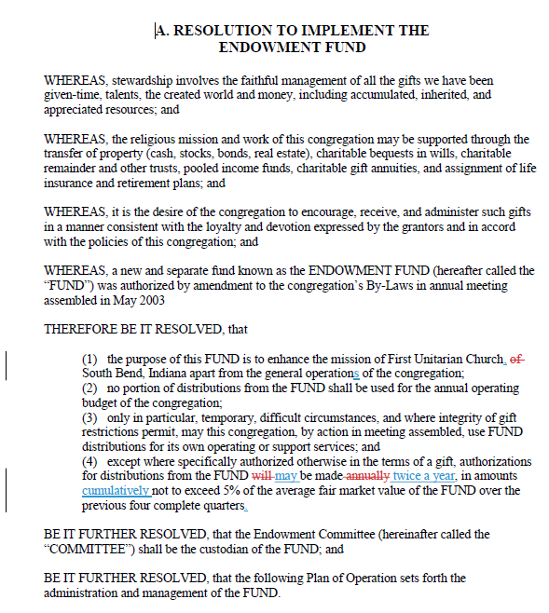
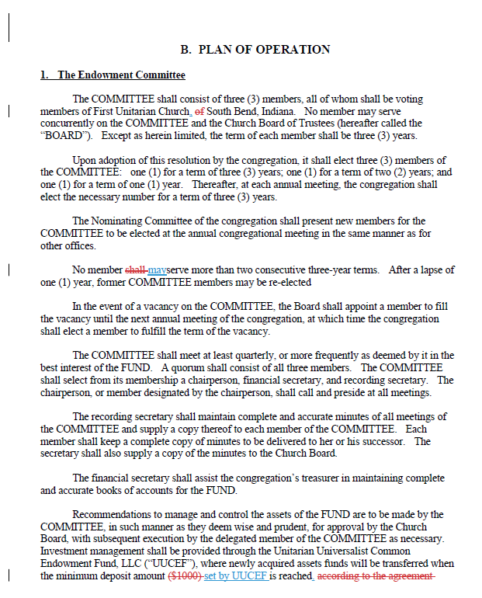
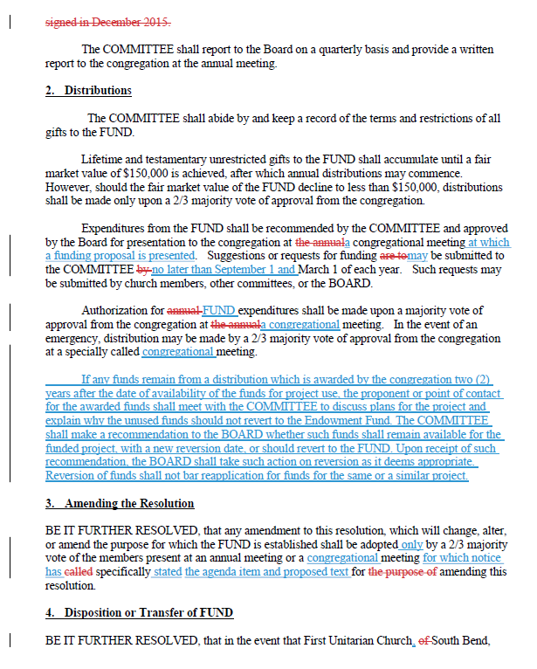

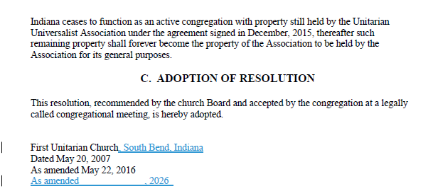

Endowment Grants
Our Recommendations for current 2026-27 Grants
- $400 Emerging Leaders Gathering
- $4000 Outdoor Signage
- $500 LGBTQ+ Quilt
- $750 Aluminum Signs & Printed Inserts
- $820 Ecology Activities (request reduced from $1275, to activities focusing on our congregational children)
- $4900 Natural Playground Addition
- $7500 75th Anniversary Celebration (excludes $5000 mural painting)
- $450 Adjustable Height Tables for RE Room
Total $19,320.
*See the Endowment Committee Report for more information.*

Proposal to Repay our Endowment
The Board of Trustees recommends that $126,268 from the Barbara Boyd funds be repaid to the Endowment fund. See the Endowment Committee Report for more information.

Funding to Repave Parking Lot
The Board of Trustees recommends that up to $69,000 be approved to repave our parking lot, $50,000 from the Rainy Day/Building Fund and $19,000 from Unrestricted Savings.

Funding for Automatic Opening Doors
The Board of Trustees recommends that up to $20,000 be approved for automatic opening doors from the Rainy Day/Building Fund to supplement the $3,800 grant money from the 2025-2026 Endowment dispersal.

Taskforce Reports
A Taskforce is a group that has been formed to address a specific short-term need for the congregation. These are often fully or in part appointed by the Board.

Minister Search Taskforce
The Minister Search Task Force was formed in July 2024 by the Board of Trustees to conduct a search for a new minister. Members Chuck Leone, Gail deSomer, Jeremiah Cox, Jim Ward, Abby Joiner and Dawn Nye were selected by the Board to serve on the Task Force and have continued to serve since that time.
During the 2024-25 church year, the Task Force gathered information to present ourselves to potential candidates. Two interested candidates were considered, but the Task Force decided in March 2025 that neither was a good fit for the congregation at that point.
During the 2025-26 church year we renewed the search process through the UUA with new parameters for the position established by the Board of Trustees. We considered a greater number of candidates who expressed interest in us through the UUA’s ministry search portal and recommended Jennifer Gray-Gracen as our next minister. She accepted our offer and her selection was approved by the Board of Trustees and by the Congregation at a Special meeting in April 2026. She will begin her service with us on August 1, 2026.
Thanks to all who participated in this process, which has helped us get to know each other better and to better define and express what we were looking for in an ongoing relationship with our new minister.
April 27, 2026 Chuck Leone, on behalf of the Task Force

Committee Reports

Administrative Committee
Chair: Florence Klečka | Members: Kyle Jaros, Barbara Williams
The Administrative Committee continued to update and review the Church’s various policies, procedures, and committee descriptions.
To do this, the Committee has a list of all committees and policies, then assign people to review them for clarity and uniformity, sending them out to the relevant committees for input and approval, then to the Board for final approval. The final documents can be found on the Church website.
Between July and May, the committee has updated the following committee descriptions:
Aesthetics, Building, Care, DREAM Team, Events, Grounds, Lifespan Learning, Social, Stewardship, and Welcoming Congregation. Others are awaiting committee or Board input/approval.
The Administrative Committee has updated the following policies/procedures:
Building Aesthetics, Building Use, Check Signing, Community Service and Activism, Memorial Fund, Memorial Garden, Memorial Service Policy and Procedures, Policy and Procedures for Non-Church-Sponsored Building Use, Volunteer Recognition. Others are awaiting committee or Board input/approval.
Once all the remaining policies and committee descriptions are approved, we can come up with a schedule of how often they should be reviewed in the future.
We also plan to organize and assign tasks in the various perpetual calendars for various committees and officers of the church, so that no one is caught unawares. There are also many procedures which should be written out.
The Administrative Committee chair is Florence Klecka. Kyle Jaros served on the committee until December, so more members are always welcome. Fern Hamlin acted as the Board liaison.

Aesthetics Committee
Chair: Melanie Smith-Guillaume | Members: Barb Carmichael, Gail deSomer, Emily Wetherall
Our committee was recently reminded not only of our own past, but of our historic connection with numerous families across the country. Toby Mcintosh, whose parents were long-time members of the church, contacted us from his home in Arlington, Virginia about a stained glass window he wished to donate.
In Toby's words: "The blue/green glass I used for the chalice was salvaged by Dale Gibson. He gave about half a dozen square pieces to my parents, Joan and Robert McIntosh, because he knew my hobby was making stained glass windows. That was at least 20 years ago and I do not recall the provenance of the glass. Perhaps it came from one of the old mansions used by the UU in the early days. Beginning in the late 1950s we attended at the Michigan and North Shore Dr. location. I recall having Sunday school classes in attic rooms of a once elegant mansion there. It was still early days and we knew many of the original founders. I am glad to have finally used Dale's glass and to send it back home."
Toby also provided us with a poem written by his mother Joan Mcintosh, a published poet, for the golden anniversary fellowship founders. We look forward to an opportunity to showcase Toby's beautiful art piece and Joan's inspiring words.

Building Committee
Chair: Kathy Vetter | Members: Gail deSomer, David Mayfield, Chuck Leone
Some years we have multiple special projects to report on. This year we kept busy just maintaining, that is maintaining the building. We only had to deal with one major unusual event this year: an ice dam on the roof above the church office. After a drying out period, David Mayfield used his construction skills to get the ceiling back in order. Thanks to our office staff for tolerating some disorder as we dealt with the problem. We still need to re-paint, so if you like to paint ceilings, please let us know.
This year we had to bring in an electrician twice: once to replace a dead sanctuary light switch and once to replace one of our emergency backup lights. We continued to use Molly Maid for our weekly cleaning. Thanks to Gail deSomer for faithfully assuring Molly Maid staff have access to the building and that they do the cleaning needed for the upcoming week. As we’ve done every year since occupying this building, we arranged for licensed professionals to test our elevator as well as our fire suppression systems – sprinklers and extinguishers – as required by code. New this year, after the Fire Department informed us of the requirement, we arranged for our fire protection vendor to test our smoke detectors and alarm pulls. We also obtained our annual state elevator permit, and assured our elevator phone is monitored 24/7 along with our security/fire protection system by our chosen vendors and that those vendors have been paid properly and know who to call in case of an alarm, etc. (those on the three-person call list we maintain).
Our biggest time commitments are to those tasks that we do ourselves on a daily, weekly, monthly, yearly or occasional basis. Weekly we set our seven thermostats based on building use and, in the winter, most days we actively monitor the building temperatures as a backup to our passive monitoring systems. We also take care of the trash and recycling every week. Monthly we test our elevator to assure it would work as it should if there was a fire. On an occasional/as needed basis we do things such as change furnace filters & light bulbs, purchase building supplies (cleaning supplies, paper supplies, light bulbs, furnace filters, etc.) and other miscellaneous tasks.
Along with our regular tasks discussed above, this year we made some progress in identifying a vendor and getting approval for having ADA-approved door opening mechanisms installed on both doors at both the West and East entries. We also explored our options for a new security system vendor, but haven’t made any decisions yet.
It really does take a village to keep our lovely building maintained so I am grateful for the dedication of our committee members and to Fern Hamlin for serving as our Board Liaison. And, I am thankful for those not on the Committee who have jumped in when needed to help with various building needs. If you would like to join this small but dedicated group who keep our building running smoothly and looking nice just let me know.
Cheers, Kathy V.

Building Use Committee
Chair: Gary Metzler | Members: Gail deSomer, Kathy Platt, Kathy Vetter, Jim Ward
The Building Use Committee evaluated non-church building use requests and for those approved, worked with the building users to create a building use agreement, opened and closed building, set up, assisted with needs, made sure all was cleaned up, and provided a presence in the building during use. For Memorial Services, the BUC communicated with the family for any needs, opened the building, was available to receive flowers, assisted with cleanup and closed the building.

Care Committee
Chairs: Gail deSomer | Members: Jim Curlee, John Mitchell
The Care Committee strives to match those who have a need with those who can help. Throughout the year, the Care Committee and its helpers assist whenever they hear of a need from members or friends. We send meals or soup to families or individuals who are sick or have surgery, or have had a baby and provide rides to appointments or physical therapy. We also assist with Memorial Services.
The Care Committee records weekly Joys and Concern and shares this with the Care Committee and its helpers. Individuals can then follow up with cards, emails, phone calls or visits. In December, Care Committee members and helpers delivered 16 poinsettias or cards to church members and friends who are unable to attend church or who had a difficult year Special thanks to Lois Holm who continues to send out Birthday cards to church members and friends throughout the year.
The Care Committee maintains a “loan closet” in the church basement near the elevator with medical equipment such as walkers, wheelchairs, canes, commodes and wedge pillows. In addition, there is baby equipment such as strollers, bed rails and pack ‘n plays for members and friends to borrow. Items can be checked out by signing your name on the clipboard hanging on the wall, and checking the item back in upon return. There is a wheelchair near the front door and one near the back door of the building for anyone who needs it while visiting the church. The Care Committee has end of life forms church members can fill out and maintains these forms in a confidential file. We are currently identifying those who would like to have regular phone calls or contacts.
Thanks to Karen Heffernan, past chair, and to Tosha Rowe and Karen Dickson for their service on the Care Committee.

Committee on Ministry
Chair: Francisco Gomez-Dossi | Members: Ann Hoewing, Cat Rambo
Our committee has now been working together for the past 18 months. The COM had been inactive since 2021-2022. There was a period of rebuilding necessary. This included reviewing and setting the duties and goals of the committee. We have completed some of these to help guide the committee in its continuing duties and goals.
We have started a review of the ministries of UUSB. This has been a very difficult task as this is defined as “Ministries means everything the congregation does to live its mission”. This is further complicated by the absence of a minister, a person who can help further define and refine this for us.
We are now in a preparation phase for fulfilling our duties as they relate to the UUSB minister. There are specific duties listed that the COM is to provide but clarification of these will be done in conjunction with the minister.
We have run several conversations on the current UUSB Covenant. Review and changes are encouraged by the UUA to be done regularly and ours has been unchanged from its inception. This remains an open topic to be further discussed congregation-wide.
We have dealt with interpersonal conflict within UUSB including assisting the BOT on expulsion of a member.
The status of our current members, which are elected by the BOT on an annual basis, is as follows: Francisco chairs through 2026-2027; Ann remains member through 2028 and chairs the committee in 2027-2028; Cat remains member through 2029 and chairs the committee in 2028-2029.
Submitted,
Francisco J Gomez-Dossi

D.R.E.A.M. Team (formerly Children and Youth Religious Education)
Chairs: Gail deSomer, Megan Sulok, Kaely Barwick
D.R.E.A.M Team signifies Directors of Religious Education and Mindfulness. The team consists of: Kaely Barwick, Gail deSomer, Cody Ruiz, Megan Sulok and Christina Tolomei who plan activities and also teach.
For our youngest children, four and under, childcare was available in the nursery provided by Max Castenada, then Patricia Kirk and now Mackenzie Van Ausdal. We average one to four children attending in this age group, with six enrolled,
Over the summer we used a play-based curriculum called Can Do Summer that focused on curiosity and imagination for all ages. In the fall we completed a curriculum called Sitting Together for our K-6th graders. It is curriculum where we explored meditation, kindness, ethics, character, service and nature/earth through stories, meditation exercises, crafts, games and song. We are currently using a curriculum called the Rainbow Connection which has lessons on our community as a treasure, our chalice, covenant, sacred spaces, generosity, honesty, awe, beauty in nature, ideas of the divine and many more. Each lesson points to one or more of our values. Once per month we offer a choice of a role play game or board games. Thank you to Syd Troyer for being a guest teacher this year, leading two classes to help fulfill the requirements for the Welcoming Congregation Certification. There are five to ten children attending on a given Sunday in this age group with around 15 enrolled.
For our 7th to 9th graders, we offered Our Whole Lives, the comprehensive sexual education program. Thank you to Tama Crisovan and Rich Wallace for teaching this class. There were six teens enrolled. OWL finished the end of April. Jim Curlee will offer The Twilight Zone curriculum monthly for this age group.
In addition to Sunday morning activities, we had social activities almost once per month in order to help the children develop a sense of belonging to a larger community. Activities included a playground meetup, assisting with weeding at the Res, joining in the UU beach day, Intergenerational Games nights, a Halloween party at Potowatami Park, and an Easter Egg Hunt in April. In November, we collected donations for the children who receive services through the CASIE Center. Thank you to Mary Beth Dickey for her continued support in this annual service project.
Thanks to a previous Endowment Grant, a balance beam was built in the back yard to play on and to wall off a garden space. More plans are in the future to improve the slide and create a tunnel under it.
We continue to use a Facebook Messenger group to communicate with parents and grandparents of children participating in Religious Education. This group serves to announce activities in addition to the Chirp. The group also allows parents to communicate with each other and build community.

Endowment Committee
Chair: Barbara Williams | Members: Vicki Stevens, Linwood Bailey
Our Priorities for 2026-27
- Promoting our congregational community & its future
- Celebrating our legacy
- Engaging the youth and families to assure succession

Considerations.
- The Endowment UUCEF fund is requesting $126,268 from the Barbara Boyd Bequest to repay the funds used from the Endowment for the building purchase, renovation, etc. This sum was reached by the initial $130,368. taken in 2013 when the building was purchased. Of that initial amount, only $8100. has been repaid to the Endowment from operating funds. However, an additional $4,000 was granted from the Endowment for the roof. In table form, we are justifying that $126,268 has been used by the Endowment to pay capital improvement of the building. We are requesting $126,268 of that be paid back from the Barbara Boyd bequest. This amount will increase the Endowment with the UUCEF so that the calculated amount for disbursement for the 2027-28 cycle will be larger than it has ever been in the past.
- Initial loan (2013) $130,368
- Roof (partial) $ 4000
- Sum $134,368
- Minus partial repayment $ -8100
- Total from Endowment $126,268
- There are a few policy changes being recommended to be approved by the congregation at the May meeting: a) permitting unused funds from previous years’ grants to be accessed for next year allocation; b) allowing for mid-year awarding of grants.

Review of the remaining balances of the previous years’ grants:
- 2019-20 Natural Playground 134.
- 2023-24 Exterior Security Upgrades 2288.
- 2024-25 Planning Expenses 2325.
Attic Insulation 1925.
- 2025-26 ADA Compliance Doors 3800.
Conf Room Tech Upgrades 668.
*Patio Covering Addition 5000.
Sound System Upgrade 826.
*Includes the BOT moving ($206.) into 2025-26
for Patio Cover

Committee recommendations for remaining prior balances
- Transfer the $134 balance for the 2019-20 Natural Playground to the 2026-27 Natural Playground Addition proposal per request of the DREAM Team.
- Return the full amount of the 2023-24 grant for Exterior Security Upgrades ($2288.) since it has been unused. The amount of $2288 should be returned to the Endowment total to be awarded this year. An updated proposal can be made in the future.
- 2024-25 grant for Planning Expenses— After checking with several folks, the proposal for this grant is elusive. Thus, the Committee recommends the balance of $2325. be returned to the Endowment total to be awarded this year.
- The 2024-25 grant for the Attic Insulation Project should be carried forward in order to meet the specifications of our insurance provider to prevent the pipes freezing.
- 2025-26 Project for the Conference Room Upgrades has been completed and thus the $668 balance can be returned to the Endowment total.
- 2025-26 Project for the Patio Cover has installed a sail on the Patio. $5000 to be returned to the Endowment total. Before considering a more permanent (and more expensive) pergola project, it might be prudent to monitor how the patio is being utilized for coffee hour/potlucks by the congregation this summer. A new proposal can be submitted for the 2027-28 cycle.
- 2025-26 Project for the Sound System Upgrade balance of $826 should be carried forward in order to complete the purchase of the additional microphones. Requested by the Tech Committee.
- 2025-26 Proposal for ADA compliance for entryway to building balance of $3800 should be carried forward.

In sum:
Carried Forward for 2026-27 | Returned to Endowment for 26-27
$134 Nat Playground | $2288 Ext Security Upgrade
$1925 Bldg Insulation | $2325 Planning
$826 Sound System | $668 Conf Room Upgrade
$3800 ADA entry | $5000 Patio Covering
Total: $6685 | Total: $10,281

The calculated Endowment possible withdrawal from the UUCEF for the 2026-27 cycle is $17,591.19. This is based on 5% of the average of the balances in the Endowment for the last 4 quarters.

8 Proposals received for 2026-27:
- Emerging Leaders Gathering: Day of Connection and Belonging for working age adults and families - $400
- Exterior Signage to reflect Unitarian Universalists of SB name and address Leaving the minister’s name blank - $4000
- LGBTQ+ Quilt for Great Hall - $500
- Three Aluminum snap edge A-Frame signs and printing of the 22 x 28 inserts - $750
- Ecology oriented activities for families and children $1275
- 75th Anniversary Celebration $12,500 (includes $5000 for a mural to be installed on east side of building).
- Adjustable height tables for RE Room 3 tables for $450.
- Natural Playground Addition $4900
Total requested $25,415

Our Recommendations for current 2026-27 Grants
- $400 Emerging Leaders Gathering
- $4000 Outdoor Signage
- $500 LGBTQ+ Quilt
- $750 Aluminum Signs & Printed Inserts
- $820 Ecology Activities (request reduced from $1275, to activities focusing on our congregational children)
- $4900 Natural Playground Addition
- $7500 75th Anniversary Celebration (excludes $5000 mural painting)
- $450 Adjustable Height Tables for RE Room
Total $19,320.

Thus we recommend
- Including the $10,281funds that have been unused if the congregation approves the changes of taking back unused funds that are more than one year unused or if the goals of the grant have been fully achieved.
- Withdrawing $9039 from UUCEF this summer. With the addition of the remaining/unused funds, the disbursements this summer total: $10,281 + $9039 = $19,320.
- Maintaining an $8552 remaining in this year’s formulaic withdrawal amount to be used for a possible 2nd award option this fiscal year if the congregation approves more than one cycle of awards per year. This change allows for more awards for emerging priorities as the year progresses.

Events Committee
Chair: Kathy Platt | Members: Jim Ward, Gail deSomer, Anne Mannix
Anyone who wants to help with events is welcome on this committee. Different people head up different events that help us have fun and develop community.
We had an Ice Cream Social following the Service on Sunday July 20, which is National Ice Cream Day. It included some home-made ice cream made by our children in RE!
August 23-24, we had the All Church Retreat at The Res in Mishawaka. Almost 80 came during the two day event. We started with Lunch on Sat., and ended Sunday afternoon after our outdoor Service in the Amphitheater and Picnic. We enjoyed indoor & outdoor games, discussions, activities like Journaling, Tai Chi, Scavanger Hunt, D&D, and a Campfire with Singing & S’mores. Planning Committee was Kaely Barwick, Alice Bentley, Jeremiah Cox, Gail deSomer, Dr. Louise, Florence Klecka, Chuck Leone, Mary Alice Lundergan, Anne Mannix, John Mitchell, Tosha Rowe, Susan Siemers, Megan Sulok, Pat Taplick, Emily Witherall, and Kathy Platt. This year’s Retreat will be August 22-23.
We had our annual Activity Fair on Oct. 12. This provides information on church committees and groups.
Lois and Dan Holm organize the Art on the Walls, which we are so fortunate to have. Please read their Art on the Walls report.
Jim Ward brings in fabulous musicians for us to enjoy! This year we had Francis Luke Accord on Oct. 10.
We had our 48th annual Service Auction Nov. 1 with the fun Halloween theme. We raised over $15,000 due to our generous donors and bidders! Jim Ward, auctioneer, Justine Backus, joke seller, Florence Klecka Dessert Competition organizer. Gail & Allen deSomer and Florence kept track of the bids. Vicki Stevens headed up the Online/Silent Auction. Ben Tover and Alison Mynsberge tended bar. SO others helped, including Jane Ash, Alice & John Bentley, Lily Bronsten, Jeremiah Cox, Brigette Gray, Lois & Dan Holm, Kathie Carr, David Mayfield, Susan Siemers, Janet Bogar, Kaely Barwick, Diana Mendelsohn, Vicki Stevens, Kelly Faust, Dawn Nye, Ron Robinson, Emily Wetherall, Ann Hoewing, Pat Taplick, Jim Curlee and Dr. Louise. SO MANY others helped with clean-up, etc. Thank you all!
Our annual Cookie Walk Sunday Dec. 8 raised $545. Thanks to all our wonderful bakers!
Anne Mannix again hosted our Holiday Potluck on Dec. 13 We had our annual Holiday luncheon at the Tippecanoe Place restaurant on Sat. Dec. 20.
Our church’s founding was Feb. 22, 1952. We celebrated our 74th Anniversary with cake and an Art Opening on Sunday Feb. 22.
There were several Family Game Nights, sponsored by RE. And monthly Sunday afternoon Board Game Socials. The Love is Love Dinner was Feb. 14. Abby Joiner & Dr. Louise hosted the Jammies & Cereal Bar Parties.
Art on the wall
We have had a variety of organizations and individual artist enjoy our gallery for their shows. 15% of sales goes into our general budget.
The new well received show was Fine Art Recycling. Art from our own folks to sell with any donation to the budget.
Allen deSomer, Dan Holm and Cindy Benedict do an amazing, and tedious job hanging each show. Lois Holm organizes and schedules the shows. Let us know if you have suggestions of artists.

Finance Committee
Chair: David Mayfield | Members: Janet Bogar, Fern Hamlin, Karen Dickson, Barbara Williams, Kathy Vetter

Grounds Committee
Chair: Francisco Gomez-Dossi | Members: Alice Bentley, Allen deSomer, Alan Hamlet, Kathy Platt, Garry Roberson, John Bentley, Gail deSomer, Grace Ruiz.

Lifespan Learning Committee
Chair: Gail deSomer | Members: Barbara Williams, Dr. Louise, Chuck Leone
The committee met in the fall to update the committee description and name and identified Educational and Spiritual events to offer throughout the program year.
Organized by the Adult Forum:
Adult Forums- met generally three out of four Sundays per month at 9 am in the church Conference room. The topics were planned quarterly by those attending. Attendance was generally around 8-12 people per forum, in person and on Zoom. The topics were on a wide range of subjects including: Why are we Here?, Transactions, Reparatory Justice, Don’t Loose Your Marbles, The Declining Birth Rate, The Benefits of Solitude, All Politics is Local, Meditation, Bring Your Favorite Gemstone or Rock, AI and Education, Highly Processed Food, Gratitude, Vulnerability, Ask a Trans Person any Question, Discussion on book Love at the Center, Testing for Citizenship and Voting, The Joy of Fine Porcelain, Current Issues in Biology, discussion of book Separation of Church and Hate, Trust, Prediction Markets, The Politics of Energy, Honoring our Grandmothers and Great Grandmothers.
Facilitators and planners include Dan Holm, Lois Holm, Jane Ash, Emily Wetheral, Chuck Leone, Kevin Warren, John Mitchell, Jim Curlee, Barbara Williams, Gail deSomer, Anne Mannix, Tamara Ciszczon, Justine Backus, Rich Williams, Cody Ruiz, Diana Mendelsohn
Organized and led by Barbara Williams:
Great Decisions, an eight-session program prepared by the Foreign Policy Association, was held in February, March and April this year. The program was very well attended including both members and friends of our church. We read articles, watched videos and discussed 8 topics of foreign policy that are most timely. Ideas and viewpoints were shared in lively discussions. All participants agreed that the program provided a context for understanding news reports. The Great Decisions program represents our congregation’s commitment to living our 2nd, 4th, 6th and 7th principles as we work for justice, equity, compassion, search for truth and meaning, support the goal of peace, liberty and justice for all, respecting and learning about interdependence throughout the world.

Other activities included:
Common Read – organized and led by Dr. Louise Williams, in a one-day workshop discussing the book Social Change Now: A Guide for Reflection and Connection. Fourteen attended either in person or on Zoom.
Meditation Group led by Justine Backus met bi-monthly or monthly
Passover Seder meal organized by Dr. Louise Williams and Jeremiah Cox with 19 attending including four children from UUSB
G.O.S.H, Group of Open-Source Happiness, a small group ministry continues to meet twice per month.

Marketing Committee
Chair: Cat Rambo & Dr. Louise | Members: Kelly Faust, Justine Backus, Abby Joiner, Grace Ruiz, Max Castaneda.
This year has been a period of meaningful growth and strategic development for the Marketing Committee as we worked to increase UUSB’s visibility, strengthen our identity, and expand our reach in the broader community. A major focus of our work has been the transition to our new public-facing name, Unitarian Universalists of South Bend. This rebranding effort has been implemented across our website, social media, publications, and merchandise, including a successful relaunch of our T-shirt shop featuring updated designs. The shop saw strong engagement and generated both revenue and increased visibility for our new name within and beyond the congregation.
In addition to strengthening our internal identity, the committee has pursued new avenues for external visibility and community engagement. We developed a sponsorship model for the Trans Day of Remembrance event that invites both faith-based and secular organizations to participate in a collaborative, values-driven event, with all funds raised directed to The Trevor Project. This initiative reflects our commitment to justice, interdependence, and building bridges across communities. It also significantly increased the financial support we were able to offer the Trevor Project, as well as contributing to the Welcoming Congregation committee’s work to make us a recognized Welcoming Congregation. We also explored and initiated partnerships designed to increase awareness of UUSB, including a pilot sponsorship of John Adams High School’s winter athletics program, placing our name in front of hundreds of local families in a way that aligns with our non-proselytizing values.
The committee also began expanding into new media and advertising spaces. We developed a relationship with WVPE public radio which included an event promotion spot for our Love is Love Dinner Date. That, along with our additional marketing efforts for Love is Love resulted in 13 folks from outside of UUSB attending - a significant improvement over last year. We are also continuing to be mentioned on WVPE as one of the many organizations that support the work of NPR.
At the same time, we launched a new podcast, UUSB Presents: The Chirp and The Chalice, which shares sermon recordings and provides an accessible audio version of our weekly communications. This initiative was created in response to feedback about communication accessibility and represents an important step in meeting people where they are.
Our team continues to regularly create both digital and physical assets to help promote UUSB. The channels that have been most successful for us include Facebook, the local South Bend subreddit, and participating in local tabling events, such as South Bend Pride, the Mind Body Festival, and South Bend’s Earth Day celebration. We continue to explore new ways of promoting UUSB in order to reach more potential members, as well as ways to make our current means more effective.
Taken together, these efforts reflect a shift toward more intentional, strategic marketing that prioritizes both visibility and alignment with Unitarian Universalist values. The Marketing Committee continues to explore new ways of connecting with our community—both within the congregation and beyond—while ensuring that our presence remains welcoming, authentic, and rooted in our shared values.

Membership Committee
Chair: Gail deSomer | Members: Jim Curlee, Kathy Platt, Jim Ward, Dr. Louise, Megan Sulok
The Membership Committee offered the Newcomers' Class both in the fall 2025 and spring 2026 followed by an Ingathering. The classes were offered in person with the option to join on Zoom.
- joining in December 2025 were Rebecca Lehmann and Josh Frye, Angie Gormely and Charolea Wood
- joining in April 2026 were Shane Black, James Griffin and Autumn Mollett
In Memoriam
- Don Wheeler, friend
Thank you to our Greeters - John and Alice Bentley, Karen Heffernan, Mary Alice Lundergan, Kathy Platt and Tom Platt, Melanie Smith-Guillaume, Linwood Bailey, Ann Hoewing and Gil Staffend with Jim Curlee as a sub.

Peace & Social Justice Committee
Chairs: Dan & Lois Holm: retiring
There are weekly donations and monthly drives to support the work of Broadway Christian Parish with the marginalized in our community.
Thank you!
Our partnership with We Make Indiana has been ongoing.
Thank you Barb Carmichael for your leadership.
The Dale Gibson Memorial Crosswalk raised $1306.56 to help feed those in need locally and around the world. Thank you walkers and donors.

Social Committee
Chair: Kathy Platt | Committee: Sharon Barrett, Alice Bentley, Gail deSomer, Jane Ash, Kaely Barwick, Susan Siemers, Karen Heffernan, Brigette Gray, John Mitchell, Carol Rybak, Cat Rambo
We are mostly about providing food and beverages at the church when people get together. Plus the newly named She & They Potluck, which meets in different homes every third Friday. And Feasters, who go out for dinner at a different restaurant each month, organized by Ann Hoewing.
Our big job is organizing Coffee/Social Hour each Sunday and the Sunday Potlucks. We are always looking for volunteers to help make Coffee or to help with Potlucks. There is a sign-up sheet in the kitchen by the refrigerator. Thanks to regulars Ben Barwick, Cody Ruiz, John and Alice Bentley, John Mitchell, Brigette Gray, and Karen Heffernan.
We also take care of the Reception following the Christmas Eve Service, thanks to Jeremiah Cox. And provide lunch for the Annual Meeting in May and any other congregational meetings.

Stewardship Committee
Chair: Gail deSomer | Members: Gary Metzler, Eli Williams
This year the Committee: prepared and mailed a letter and brochure regarding the pledge drive to members and friends, prepared the online pledge form, prepared announcements for the Chirp, arranged for Stewardship Moments (2-3 minute talks by members) during Church services, arranged for a Stewardship sermon, organized and hosted the Stewardship Brunch, organized and hosted an Appreciation Event, and prepared and mailed Thank You cards.
Total pledged for the 2026–2027 fiscal year: $151,504, representing an increase over the previous year and reflecting the continued commitment of our congregation.
We extend our sincere thanks to all who pledged and to the many volunteers who helped with the pledge drive. Your generosity enables the church to meet its financial commitments and to thrive into the future.

Sunday Service Committee
Chair: Anne Mannix | Members: Neal Austin, Ian Bunker, Francisco Gomez- Dossi, Cat Rambo, Megan Sulok, Jim Ward, Barbara Williams.
In some ways, it has been a long year without a minister. However, the Sunday Service Committee has expert assistance and active members and we made it through. Rev. Byrd Tetzlaff and Rev. Gy filled in with services. As experienced ministers, they added polish and solid content. Ian Bunker performed the music and coordinated guest musicians. Committee members and others did some excellent services. The average attendance since January, including those on Zoom was 80 people per service. We hope that people walked out with something to remember and information that enriched their lives. Thanks to everyone for their tolerance and we look forward to finishing out the summer with good services and working with Rev. Jennifer Gray-Graycen in the new church year.
From Cat Rambo: This year, I took part in the Shared Pulpit program led by Erika Hewitt (https://www.uua.org/worship/lab/shared-pulpit), designed to teach lay members how to write sermons. We met each month for three-hour sessions; the last one is in June. My intent has been not just to learn how to write sermons but also how to facilitate this program for our congregation in the future.

Technology Committee
Chair: Jeremiah Cox | Members: David Mayfield, Alan Hamlet
The technology committee’s major projects this year involved overseeing two endowment grants, a new sound system for the sanctuary, and a new television screen for the conference room. It also helped install two old computers that were generously donated to the congregation for Zoom hosting and help with adult Religious Education.
The new sound system was purchased for the church and gives the church a state of the art sound system so today we no longer need to borrow or rent equipment during concerts.
The new conference room television screen allows better audio/visuals in the conference room. This has installed a new large 8K television on the wall. This screen in the conference room can be connected to via an HDMI cable to a laptop, including the ability to show participants on the meeting owl on the screen, by casting from a smart phone (it’s a smart TV). A new DVD player with Blu-Ray capabilities (in addition to the ability to play older DVDs) was also purchased and installed in the conference room.
The congregation also received the donation of two computers just over a year ago. This year technology committee was able to put them to good use. One of these computers has been set up on a cart with a television to make this television a smart TV that is primarily used by Religious Education. The other has been set up in the sanctuary so there is now a computer for Zoom hosts. This makes Zoom hosting more equitable by no longer requiring Zoom hosts to bring their own computer. The technology committee also acquired two pairs of headphones for the sanctuary. One is for Zoom hosts and one is for the Sound board.
Goals for the next year include looking into new solutions for hosting YouTube and other video content during services. The goals are trying to reduce the buffering time that today sometimes happens. The technology committee also looks forward to working with the new minister and making sure all of her technology needs are met.

Welcoming Congregation Committee
Chair: Eli Williams & Dawn Nye | Members: Rev. Byrd Tetzlaff (she/her), Kelly Faust (she/her), Tosha Rowe (she/they), Syd Troyer (they/them), Jim Ward (he/him), Sylvia Mayfield (she/her), Bobbie Gardner (she/her), Carol Stuart (she/they), James Griffin (she/they), Cat Rambo (they/she), Karen Heffernan (she/her)
At UUSB’s annual meeting, we will vote on whether we desire to be officially recognized as a Welcoming Congregation by the Unitarian Universalist Association. This signifies our support of lesbian, gay, bisexual, transgender, questioning/queer, intersex, and asexual (LGBTQIA+) people. We also honor the experiences and concerns of transgender, non-binary, genderqueer, and genderfluid individuals in our congregation and beyond. We are hoping for a unanimous vote in favor. To become a Welcoming Congregation, we must follow five steps outlined by the UUA each year.
The Five Practices of Welcome Renewal are:
- Become a Welcoming Congregation
Becoming a Welcoming Congregation is the expectation of every Unitarian Universalist congregation. While over 800 congregations are currently “approved,” the nearly 300 congregations that are not are encouraged to fulfill the original objectives of the Welcoming Congregations application.
- Welcoming Worship Services
The second Practice of Welcome Renewal is incorporating Welcoming Worship Services into our ordinary calendar of worship every year. These services might occur during LGBTQ+ Pride Month or any other day of observance. An LGBTQIA+ marriage ceremony, naming ritual, or remembrance ceremonies may also fulfill this objective.
- Welcoming Days of Observance
The third Practice of Welcome Renewal is an annual recognition and celebration of the Welcoming Days of Observance. These days and seasons are important to LGBTQIA+ communities because they bring visibility and affirmation after generations of invisibility and erasure. These days remind all that “All of who you are is sacred. All of who you are is welcome.”
- Welcoming Religious Education
The fourth Practice of Welcome Renewal is an annual opportunity for your congregation to experience a Welcoming Congregation Module. A WC module is a UUA approved seminar / webinar. Each year the UUA LGBTQ program office will offer at least one Welcoming Webinar engaging LGBTQIA+ issues and topics. Welcoming Congregations may register for a webinar or may chose to sponsor a local seminar for its local congregation and community.
- Support a Welcoming Project
The fifth Practice of Welcome Renewal is Support a Welcoming Project. Welcoming Congregations (WCs) are congregations that give generously of our gifts and resources. To remain current, WCs may donate a sizable donation to a local and national organization, campaign, or project that uplifts the dignity of LGBTQIA+ communities.
Our Welcoming Congregation Committee, among many other committees and individuals at UUSB, has worked diligently to achieve these goals. We have taught LGBTQIA+ religious education classes for both youth and adults, applied for an endowment grant for a Pride quilt, hosted Transgender Day of Remembrance, donated to the Trevor Project, held the third annual Love is Love dinner, mounted a pride flag outside our building, and conducted multiple LGBTQIA+ sermons. Looking forward, we will be tabling at South Bend Pride and Jim Ward will lead a service on the lasting impact of the AIDS crisis.
Pending congregational approval, the Welcoming Congregation Committee will annually ensure that UUSB meets the requirements to renew Welcoming Congregation status. Renewal will be achieved through steps laid out by the Unitarian Universalist Association. The committee’s purpose is to help members of the LGBTQIA+ community feel welcomed, valued, and included for their individuality and contributions. We recognize we are a stronger group when we have a diverse congregation.

Congregation Wide Project Reports
Congregation Wide Projects are major initiatives – such as events or fundraisers – that span multiple committees and receive approval and overarching support from the Board of Trustees, even though the board is not typically involved in day-to-day execution

Love is Love Dinner Date Report
February 14, 2026
The Love is Love Dinner Date took place on February 14 and continues to be a successful community-building and fundraising event for UUSB. This year we sold 42 tickets, including both sponsored seats and regular ticket sales. Of these, 13 tickets were purchased by individuals outside the UUSB community, representing a notable increase in external participation from last year. Additionally, 9 tickets were purchased by UUSB community members who were unable to attend but sponsored seats for others, helping expand access to the event.
This year’s event included six tables, one more than last year. Each table had a dedicated server, which worked well operationally. Two youth from the congregation, Michael and Lily Bronsteen, joined the serving team this year and were a welcome addition.
Financial Summary
Total Revenue: $1,195.55
Total Expenses (excluding marketing): $302.81
Net Revenue: $892.74
Expenses remained low due to strong volunteer support and the ability to produce print materials in-house. The increase in revenue compared to last year is partly attributable to the addition of an extra table.
Alcohol sales were offered but ultimately broke even.
Marketing & Outreach
A major innovation this year was the use of a WVPE promotional spot, funded through a previous Pass-the-Plate collection. While only a small number of ticket purchases came directly from the ad, several people reported learning about UUSB through the promotion, suggesting the spot served as effective broader outreach.
Event Operations
Several operational improvements contributed to a smoother event this year:
- A comprehensive event checklist was developed and will be a helpful planning tool going forward.
- Volunteers were asked to arrive at 6:00pm for a 6:30pm start, which allowed time to address last-minute needs and significantly reduced stress during setup.
- Instead of hiring a police officer as in previous years, the Safety Team staffed the entrance, checking guests against the ticket list. This worked well. In the future, only one safety volunteer may be necessary, ideally integrated into other volunteer tasks once check-in is complete.
An ice dam at the main entrance required closing the front walkway, highlighting the need for wind-resistant sandwich boards to communicate directional information during events. This request has been passed along to the Marketing Committee.
Event Timing & Cleanup
This was the first year the event was held on a Saturday evening, which created some logistical challenges because the building needed to be fully reset for Sunday service immediately afterward. Cleanup for this event is already extensive, and by the end of the evening most volunteers are understandably exhausted.
For future events, the team recommends recruiting dedicated cleanup volunteers so that those who worked during the event are not responsible for the entire reset.
Ticket sales were also somewhat slower this year, which may have been influenced by holding the event on Valentine’s Day itself. In future years, the team recommends considering the Friday before Valentine’s Day, which may make it easier to sell tickets earlier and position the event as a way to celebrate the holiday.
Food Service & Setup
The table settings remain the most labor-intensive component of the event, requiring significant volunteer coordination. Maintaining elevated table settings continues to be important for distinguishing the event from typical potlucks held in the same space.
To simplify setup in future years, Kathy Platt suggested using the small crystal plates inherited from another nonprofit instead of maintaining separate appetizer and dessert plates. This would reduce volunteer workload and prevent mismatched plate settings.
The mocktail station was less popular this year. If offered again, it would benefit from pre-planned drink options and a volunteer dedicated to mixing beverages for guests.
Separately, the event would benefit from a designated “front of house” volunteer responsible for answering guest questions, directing guests, and managing event flow. This role was informally filled by Dr. Louise while also hosting a table, which proved challenging.
Dietary Needs
Dietary accommodations continue to arise each year even when not anticipated. Currently, guests must request accommodations individually and the team then works to meet those needs.
For future events, it would be beneficial to:
- Plan at least one dish that meets a wide range of dietary needs, and
- Systemize how dietary needs are collected during registration and clearly communicate that accommodations are available.
Accessibility & Sponsorship
The seat sponsorship model helped expand participation but developed somewhat organically this year. The Love is Love planning team has reached out to the Equity Task Force to explore ways to better structure this process for future events.
The team also identified an opportunity to add a dedicated kids’ table in the future. This would allow children attending with their families to sit together and could create a fun environment that strengthens connections among younger members of the congregation. The team plans to explore coordinating this with the DREAM team, and it is unlikely this addition would significantly increase event expenses.

Volunteer Contributions
This event relied heavily on volunteer contributions and donated food items. Special thanks to:
- Kitchen Leadership - Kathy Platt
- Cleanup - John Mitchell
- Servers - Michael Bronsteen, Lily Bronsteen, Megan Sulok, Dr. Louise, Florence Klecka, Jeremiah Cox
- Table Setting - Francisco & Joel Gomez Dossi, Jane Ash, Florence Klecka, Janet Bogar, Anne Mannix
- Safety Team - Ben Barwick, James Griffin
- Music - Ben Tovar
- Bartenders - Tama and Rich
- Food Contributions Chuck Leone – appetizer; Kali’s mother – appetizer; Alice Bentley & Kathy Platt – vegetable tray; Florence Klecka – brownies; Alice Bentley – dietary needs desserts; Kathy Platt - Tiramisu, Side Salad & Dietary Needs Entree; Gail deSomer - Mocktail supplies
The continued success of this event reflects the generosity and collaboration of many members of the UUSB community.

Report on the Trans Day of Remembrance
November, 20, 2025
We had about 100 people attending including guests and volunteers. We raised a total of $3,024.82 for the Trevor Project. At our last most similar event, the Trans Day of Visibility in March 2025 we had about 60 folks attending, so this was a significant increase in participants. Many folks from outside of our community participated while church members were well represented. Although we had planned to promote the event via NPR this did not end up happening for technical reasons, so it is reasonable to anticipate if we choose to do so in the future attendance will be higher. Interestingly, the demographics of our participants skewed more toward older cis folks whereas the Trans Day of Visibility skewed more toward younger trans folks. The reasons for this are a bit unclear but may be related to the Remembrance event being a somber affair where Visibility is more of a party. This may be something to consider when selecting speakers for these events in the future.
The Safety Team’s process for helping folks safely enter the building worked well. Since there were no significant challenges with this process, we recommend that it be adopted for future events. We did have Detective Stephanie Northcutt on site with us and reachable via walkie-talkie, but fortunately we did not need to call on her for any assistance. At least some participants were surprised by our clear bag policy. This means we should more clearly communicate this is our process – especially when working with our faith partners. Of the 100 folks who participated only one individual made negative remarks about our process and ended up leaving rather than complying. It is unfortunate that this happened, but it does show that the vast majority of folks were willing to comply. And at the end of the night, several folks thanked the team for their efforts.
Feedback on the event was quite positive. One member of our congregation remarked online: "It was amazing. A solid number of people, most not from our congregation, but still a good representation of our members. The service was beautifully done, and the music was lovely. The reading of the names was gut-wrenching, but in a good way, if that makes sense. Lots of people hung out for the reception, where the refreshments were lovely and ample, and there were no security problems as far as I could tell, so they were handled smoothly if there were. My mother, who is still figuring out a lot of this stuff, thought it was really moving. So many kudos to everyone involved; the event represented our UU values well."
Several of our sponsor organizations were present the night of the event and all of our faith partners were represented in the service. Some organizations that were not officially sponsors but have had relationships with the UU in the past were also present like the Ripple Effect Choir. Several groups left expressing a desire to partner with us in the future. This event succeeded in helping position the UU as a connection point among local organizations that are in alignment with our values. Since that event, the ACLU has reached out to our Peace and Social Justice Team looking for partnership for a project center on housing insecurity for trans folks.
Should the UU decide to do this event or a similar event in the future some important lessons were learned:
- Check requests take a minimum of 3 weeks to process with our current system. This has caused friction with our speaker being paid in a timely way. Require that the speaker communicate mileage well in advance of this deadline and ideally finalize the check request a full month in advance of the event.
- Managing the Sponsorship side of things is time intensive. While administrative aspects of this can be done through the office, it would be best if projects using this model had a volunteer dedicated to managing just this aspect of the event. This would more smoothly facilitate connecting with a wide range of sponsors and meeting their needs such that they pay in a timely fashion.
- Fundraising for the Trevor Project was good in so far as it is a recognizable organization, but many folks would have preferred finding a more local organization to fundraise for. Consider what if any local organizations might be a good fit in the future.
- Whenever possible, events that target a particular marginalized group need to have a good amount of representation of that group on the planning team. And the folks on the team who do not share that identity need to be mindful of that dynamic when disagreements arise. This TDOR took the strategy of a series of open meetings; however, this was somewhat time intensive and required getting the attention of the entire congregation. A more targeted approach may be better in the future.
- The content of this event is very similar to a Sunday Service. It may make sense for this event to be more directly connected to the Sunday Service Committee in the future since they already have a lot of infrastructure to facilitate and streamline these processes.
Thank you to everyone who helped make this event a success:
- The Planning Committees: Sylvia Mayfield, Max Castenada, Shane Black, Autumn Mollett, Tosha Rowe, Justine Backus, John and Alice Bentley, Syd Troyer, John Mitchell, Cat Rambo, Jim Ward, and Karen Heffernan.
- The Safety Team: James Griffin, Ben Barwick, Megan Sulok, Nate Uvalles, Nick Morgan, Gail deSomer, Jim Curlee, and Dr. Louise
- Sound and Zoom hosts: Neal Austin, Jeremiah Cox, and Francisco Gomez-Dossi.
- We appreciated the music provided by Allen DeSomer and the wonderful reception after the service organized by Kathy Platt, with many donating cookies.

